### **Context Model for News Aggregation System (NAS)**

The context model for the **News Aggregation System (NAS)** illustrates the relationships and interactions between the system, its users, and external components. The central component, **NAS**, represents the software system that aggregates, categorizes, and presents news articles from multiple sources. It interacts with various user roles and external systems to provide a seamless news consumption experience.

### 

### **Users:**

1. **General Readers (A):**
   * Individuals who use NAS to access consolidated news views.
   * They can filter, sort, and read articles, view sentiment analysis, and access summaries.
2. **Journalists (B):**
   * Professionals who rely on NAS to gather diverse perspectives on events for reporting.
   * They can access real-time updates, source verification, and sentiment analysis.
3. **Researchers (C):**
   * Academics use NAS to analyze trends in media coverage.
   * They can filter articles by date, source, and relevance, and access sentiment analysis for research purposes.
4. **Investigators (D):**
   * Individuals researching news for legal, security, or forensic purposes.
   * They rely on NAS for verified sources and comprehensive coverage of incidents.
5. **National Policymakers (E):**
   * Government officials use NAS to monitor news for policymaking.
   * They can access real-time updates and sentiment analysis to gauge public opinion.
6. **Politicians (F):**
   * Elected representatives who use NAS to monitor media coverage and public sentiment.
   * They can filter news by source and relevance to stay informed.
7. **System Administrators (G):**
   * Responsible for maintaining and updating the NAS system.
   * They manage source verification, manual categorization, and system performance.

### 

### **External Systems:**

1. **News APIs (H):**
   * External APIs that provide news articles from various publishers.
   * NAS integrates with these APIs to collect news data.
2. **RSS Feeds (I):**
   * RSS feeds from news websites that NAS uses to gather articles.
   * These feeds provide real-time updates on breaking news.
3. **Web Scraping Tools (J):**
   * Tools used by NAS to extract news articles from public websites.
   * These tools help in collecting articles that are not available via APIs or RSS feeds.
4. **NLP Engine (K):**
   * External Natural Language Processing (NLP) services are used for headline categorization, sentiment analysis, and summary generation.
   * The NLP engine processes article content to group articles under unified headlines and generates insights.
5. **Cloud Infrastructure (L):**
   * Cloud-based servers and storage that host the NAS system.
   * This infrastructure supports scalability, performance, and reliability.

### **Modules:**

1. **News Collection (M):**
   * This module gathers articles from APIs, RSS feeds, and web scraping tools.
   * It extracts article titles, content, metadata, and publication dates.
2. **Headline Categorization (N):**
   * This module uses NLP techniques to group articles under incident-based headlines.
   * It allows administrators to manually categorize articles if needed.
3. **Source Verification (O):**
   * This module verifies the credibility of news sources by checking them against predefined criteria.
   * It flags potentially unreliable sources for further review.
4. **Filtering and Sorting (P):**
   * This module allows users to filter and sort articles based on date, source, and relevance.
   * It provides options to sort by "Most Recent" and "Most Relevant."
5. **Real-Time Updates (Q):**
   * This module ensures that breaking news is updated in real time.
   * It periodically checks for new articles and updates the system accordingly.
6. **Sentiment Analysis (R):**
   * This module analyses the sentiment of news articles using NLP.
   * It generates sentiment scores that help users understand the tone of the news.
7. **Summary Generation (S):**
   * This module generates concise summaries of news articles using NLP.
   * It helps users quickly grasp key insights from long articles.
8. **User Engagement (T):**
   * This module provides features like user accounts, preferences, and feedback.
   * It enhances user experience by allowing customization and interaction.

### **Hardware & Software:**

1. **Hardware (U):**
   * Represents the hardware requirements for NAS, including servers, storage, and networking infrastructure.
   * These components are hosted on cloud platforms for scalability and reliability.
2. **Software (V):**
   * Includes the operating systems, web servers, programming languages, and database management systems (DBMS) required to support NAS.
   * The software stack also includes third-party libraries for NLP, web scraping, and API integrations.

### 

### 

### 

### 

### 

### 

### 

### 

### 

### 

### 

### **Context Model Diagram**

The context model provides a high-level view of how different user roles interact with the NAS system and how external systems and modules support its functionality. Below is a textual representation of the context model:

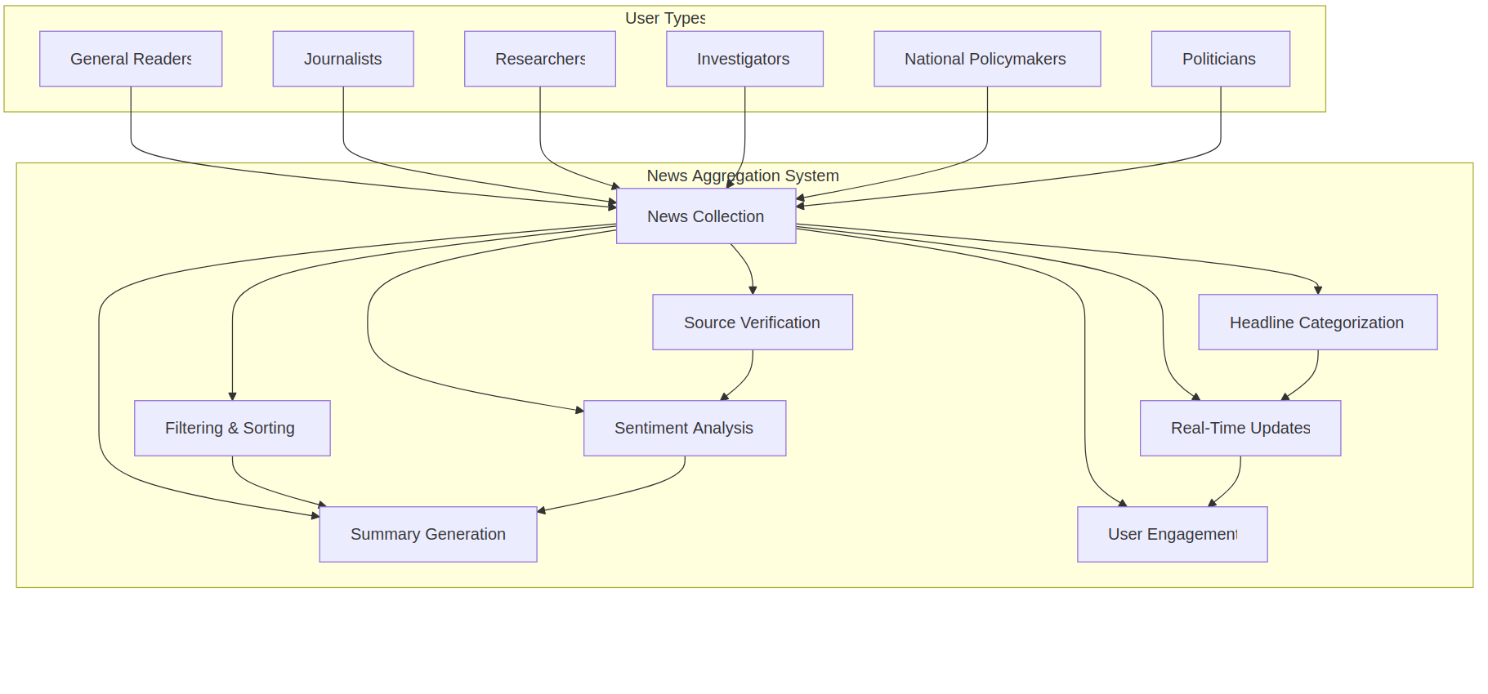

### **Interactions:**

* **Users (A-G)** interact with the **NAS** system to access news articles, filter and sort them, and view sentiment analysis and summaries.
* **NAS** interacts with **external systems (H-K)** to collect news articles, perform NLP tasks, and store data in the cloud.
* **System Administrators (G)** manage the system, including source verification and manual categorization.